

Project – High level design
On
Logistic Management System

Course name: DevOps Foundation

Medicaps university – Skill based course

Submitted by:
Sno. | Name | Enrollment no.
1. | Rupali Pal | EN24CA5030144
2. | Sumit Lakhera | EN22IT301110
3. | Rohit Solanki | EN22IT301083
4. | Kunal Shinde | EN23IT3L1001

Group name: Group 07D12
Project number: DO-45
Industry mentor name: Vaibhav
University mentor name: Akshay Saxena
Academic Year: 2025-26

Table of Contents
- Introduction.
  - Scope of the document.
  - Intended Audience
  - System overview.
- System Design.
  - Application Design
  - Process Flow.
  - Information Flow.
  - Components Design
  - Key Design Considerations
  - API Catalogue.
- Data Design.
  - Data Model
  - Data Access Mechanism
  - Data Retention Policies
  - Data Migration
- Interfaces
- State and Session Management
- Caching
- Non-Functional Requirements
  - Security Aspects
  - Performance Aspects
- References

1. Introduction
The Logistics Management System is a desktop-based application developed using Python and the Tkinter graphical user interface (GUI) framework. The system is designed to manage shipment records efficiently through a simple and interactive interface.
The application enables users to add, update, delete, and view shipment details while storing data locally using file handling techniques. The primary objective of the system is to replace manual record-keeping methods with a digital solution that improves accuracy, organization, and efficiency.
This document provides the High-Level Design (HLD) of the system, describing its structure, modules, architecture, and overall workflow.

1.1 Scope of the Document
This document presents the High-Level Design of the Logistics Management System. It outlines:
- The overall system architecture
- Major system components and modules
- Workflow and data flow within the system
- Technology stack used
- System assumptions and limitations
The document focuses on the structural and functional overview of the system rather than detailed code-level implementation. It is intended to provide a clear understanding of how the system is organized and how different components interact with each other.

1.2 Intended Audience
This document is intended for logistics firms, delivery service providers, and customers who require an efficient system for managing and tracking shipment records.
For logistics firms, this system provides a structured way to manage shipment information digitally instead of maintaining manual records. It helps staff members organize shipment details, update delivery status, and maintain accurate records in a systematic manner.

For customers, the system ensures that shipment information is properly recorded and updated. Although the current version is a desktop-based application designed for internal use, it demonstrates how shipment tracking and record management can be handled efficiently in a logistics environment.
Additionally, this document may also be useful for developers, project evaluators, and academic reviewers who need to understand the system’s architecture and functionality.

1.3 System Overview
The Logistics Management System is a standalone desktop application that operates without requiring an internet connection. It is built using Python and follows a structured layered architecture consisting of:
- Presentation Layer (GUI using Tkinter)
- Application Logic Layer (Python functions and classes)
- Data Storage Layer (Local file handling)
The system allows users to perform the following core operations:
- Add new shipment records
- View existing shipment details
- Update shipment information
- Delete shipment records
All shipment data is stored locally in a file, ensuring data persistence even after closing the application.
The system is designed for small-scale logistics management and academic demonstration purposes. It emphasizes simplicity, usability, and practical implementation of core programming concepts.

2. System Design
The System Design of the Logistics Management System describes the overall structure, internal components, and interaction between different modules of the application. The system is designed using a layered architecture to ensure simplicity, maintainability, and scalability.
The application is developed as a standalone desktop solution using Python and Tkinter, with local file-based storage for data persistence.

2.1 Application Design
The application follows a three-layer design model:

1. Presentation Layer (GUI)
- Developed using Tkinter.
- Handles user interaction.
- Contains:
  - Labels
  - Input fields (Entry widgets)
  - Buttons (Add, Update, Delete, View)
  - Display area for shipment records
This layer is responsible for collecting input from users and displaying processed results.

2. Business Logic Layer
- Implemented using Python classes and functions.
- Performs:
  - Input validation
  - CRUD operations (Create, Read, Update, Delete)
  - Data formatting
  - Error handling
This layer processes user requests and controls application flow.

3. Data Layer
- Uses local file handling.
- Responsible for:
  - Writing shipment records to file

  - Reading stored records
  - Updating and deleting data
This layer ensures data persistence.

2.2 Process Flow
The process flow of the system defines how user actions are handled step-by-step:
- User launches the application.
- GUI window is displayed.
- User enters shipment details.
- User selects an operation (Add / Update / Delete / View).
- System validates the input.
- Appropriate function is executed.
- Data is stored or retrieved from the file.
- Confirmation or output message is displayed.

2.3 Information Flow
The information flow describes how data moves within the system:
User Input → GUI Layer → Business Logic Layer → File Storage → Business Logic Layer → GUI Output
Explanation:
- The user provides shipment data.
- GUI sends data to processing functions.
- Logic layer processes and interacts with file.
- File returns stored or updated data.
- Final output is displayed to the user.

2.4 Components Design
The system is divided into the following components:

1. Main Window Component
- Initializes GUI.
- Organizes layout and widgets.

2. Input Component
- Accepts Shipment ID, Destination, and Status.
- Performs basic validation.

3. CRUD Operation Component
- Add Shipment Function
- View Shipment Function
- Update Shipment Function
- Delete Shipment Function

4. File Handling Component
- Save data to file
- Read data from file
- Rewrite file during updates/deletions

2.5 Key Design Considerations
The system design is based on the following important considerations:

1. Simplicity
The application is designed to be simple and easy to use, suitable for small logistics firms and academic demonstration.

2. Data Persistence
Local file storage ensures that data remains saved after closing the program.

3. Modularity
Functions are separated logically to make the code readable and maintainable.

4. Performance
Since the application handles small datasets locally, performance remains fast and efficient.

5. Usability
The GUI is designed to be intuitive with clearly labeled buttons and input fields.

2.6 API Catalogue
Since this is a standalone desktop application, it does not use external web APIs. However, the internal functional APIs (methods/functions) include:
Function Name | Description
add_shipment() | Adds new shipment record
view_shipments() | Displays all stored shipments
update_shipment() | Updates existing shipment data
delete_shipment() | Deletes selected shipment
save_to_file() | Writes data to storage file
load_from_file() | Reads data from storage file
These internal APIs allow smooth communication between the GUI layer and data layer.

3. Data Design
The Data Design of the Logistics Management System defines how shipment data is structured, stored, accessed, and maintained within the application. Since the system is a desktop-based application, it uses local file storage instead of a centralized database.
The data design ensures simplicity, persistence, and efficient retrieval of shipment information.

3.1 Data Model
The system follows a simple structured data model where each shipment record contains the following attributes:

Shipment Entity
Field Name | Data Type | Description
Shipment_ID | String | Unique identifier for each shipment
Destination | String | Delivery location of the shipment
Status | String | Current shipment status (e.g., Pending, In Transit, Delivered)

Data Structure
Each shipment record is stored as a structured line in a local file.
The Shipment_ID acts as a primary identifier to uniquely distinguish each shipment.
This simple data model is sufficient for small-scale logistics management and academic demonstration purposes.

3.2 Data Access Mechanism
The system uses file handling operations in Python to access and manage data.

Data Writing
- When a new shipment is added:
  - The system opens the file in append mode.
  - Writes the new record.

  - Closes the file after saving.

Data Reading
- When viewing shipments:
  - The file is opened in read mode.
  - All records are retrieved and displayed in the GUI.

Data Updating
- The system:
  - Reads all records.
  - Modifies the selected record in memory.
  - Rewrites the entire file with updated data.

Data Deletion
- The system:
  - Reads all records.
  - Removes the selected shipment.
  - Rewrites the updated list into the file.
This mechanism ensures consistency and proper synchronization between the GUI and stored data.

3.3 Data Retention Policies
The system follows a simple data retention policy:
- Shipment records remain stored permanently in the local file.
- Data is retained until manually deleted by the user.
- No automatic deletion or expiration of records is implemented.
- Backup mechanisms are not automated but can be done manually by copying the data file.
Since this system is designed for small-scale usage and academic purposes, advanced archival or regulatory retention policies are not implemented.

3.4 Data Migration
Currently, the system does not support automated data migration to external databases or cloud storage. However:
- The local data file can be manually transferred to another system.
- Data can be migrated to a database (such as MySQL or SQLite) in future enhancements.
- The structured format of stored records allows easy conversion into database tables if required.
Future improvements may include:
- Database integration
- Cloud-based storage
- Multi-user data synchronization

4. Interfaces
The Interfaces section describes how different components of the Logistics Management System interact with users, hardware, and other software components. Since this is a standalone desktop application, the system mainly interacts with users and the local file system.
4.1 User Interface
The Logistics Management System provides a Graphical User Interface (GUI) developed using the Tkinter framework in Python.

Key UI Elements:
- Main application window
- Labels for field identification
- Entry fields for input (Shipment ID, Destination, Status)
- Action buttons (Add, Update, Delete, View)
- Display area for showing shipment records
- Message boxes for confirmation and error handling
The user interface is designed to be:
- Simple and easy to navigate
- Visually clear and organized
- Suitable for logistics staff and basic computer users
The GUI acts as the primary interface between the user and the system.

Screenshot of GUI:

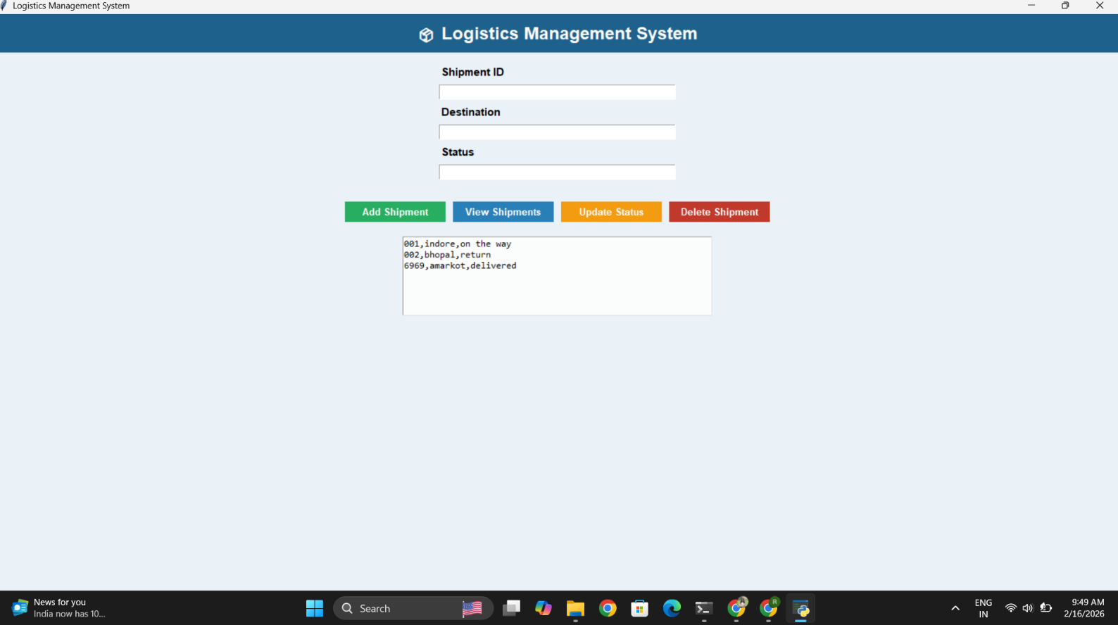

5. State and Session Management
State and Session Management defines how the system maintains data consistency and manages user interaction during application runtime. Since the Logistics Management System is a standalone desktop application, it uses a simple state management approach without complex session tracking.

5.1 Application State Management
The application maintains two types of state:
  - Runtime State
This state exists only while the application is running.
It includes:
- Current user inputs (Shipment ID, Destination, Status)
- Loaded shipment records in memory
- Active GUI window and user interactions
When the application is closed, the runtime state is cleared from memory.
  - Persistant State
Persistent state refers to data that remains saved even after the application is closed.
In this system:
- Shipment records are stored in a local file.
- Data is retained permanently unless manually deleted.
- When the application restarts, stored records are loaded from the file.
This ensures data continuity across multiple sessions.

5.2 Session Management
Since the system is a single-user desktop application:
- No login or authentication session is implemented.
- No user account tracking is required.
- Each time the application is opened, it starts a new session.
- The session ends when the application window is closed.
There is no server-based session control because the system does not operate over a network.

5.3 Data Consistency Handling
To maintain consistency:
- Data is read from the file before performing update or delete operations.
- After modification, the file is rewritten with updated data.
- Proper file opening and closing operations ensure no data corruption.
This ensures that stored records remain accurate and synchronized with the GUI.

5.4 Error and State Handling
The system includes basic state validation:
- Prevents empty input fields.
- Displays error messages for invalid actions.
- Shows confirmation messages after successful operations.
These measures ensure controlled application behavior and prevent unexpected state changes.

6. Caching
Caching refers to the temporary storage of data in memory to improve system performance and reduce repeated data access operations. In the current version of the Logistics Management System, advanced caching mechanisms are not implemented; however, basic in-memory data handling acts as a lightweight caching layer during runtime.
6.1 Runtime In-Memory Caching
When the application performs operations such as:
- Viewing shipment records
- Updating shipment data
- Deleting shipment records
The system reads data from the local file and temporarily stores it in memory (e.g., in lists or variables). This temporary storage acts as a simple cache during the active session.
This approach:
- Reduces repeated file reads during a single operation
- Improves response time
- Simplifies data modification before rewriting to file
However, this cached data exists only while the application is running.
6.2 No Persistent Cache Layer
The system does not implement:
- Database caching
- Distributed caching
- Memory cache frameworks (e.g., Redis)
- Browser or network caching
Since the application is a standalone desktop solution handling small datasets, advanced caching mechanisms are not required.
6.3 Cache Consistency
To ensure data consistency:

- The file is re-read before update or delete operations.
- After modification, the entire file is rewritten with updated data.
- The in-memory data is cleared when the application closes.
This prevents outdated or inconsistent data from being displayed.
6.4 Future Enhancement Possibilities
In future versions, caching improvements may include:
- Maintaining an in-memory list of shipment records throughout the session
- Implementing a lightweight local database (e.g., SQLite)
- Adding intelligent refresh mechanisms to optimize performance
These enhancements would be useful if the system scales to handle large datasets.

7. Non-Functional Requirements
Non-Functional Requirements define the quality attributes of the system. These requirements focus on how the system performs rather than what it does. For the Logistics Management System, the key non-functional aspects include security and performance.
7.1 Security Aspects
Although the current system is a standalone desktop application, basic security considerations are included to ensure safe and reliable operation.
Data Integrity
- Shipment records are stored in a structured format.
- Proper file handling ensures that data is written and read correctly.
- Update and delete operations rewrite the file to maintain consistency.
Input Validation
- The system validates user inputs.
- Prevents empty or invalid entries.
- Displays error messages for incorrect operations.
Controlled Access
- The application runs locally on a single system.
- Access is restricted to users who have physical access to the computer.
- No remote or network access is provided.
Data Protection (Current Limitation)
- No encryption is implemented.
- No password authentication system is included.
- Data is stored as a local file and can be accessed directly if the file is opened manually.
Future Security Enhancements
- User login authentication
- Role-based access control
- File encryption
- Database integration with secure credentials

7.2 Performance Aspects
The system is designed for small-scale logistics management and performs efficiently under limited workload conditions.
Fast Response Time
- CRUD operations execute instantly for small datasets.
- File-based storage ensures quick read and write operations.
Low Resource Usage
- Lightweight application.
- Minimal CPU and memory consumption.
- Runs smoothly on standard desktop systems.
Scalability (Current Scope)
- Suitable for small to medium dataset sizes.
- Performance may reduce if handling very large numbers of records due to file rewriting operations.
Reliability
- The system performs consistently during runtime.
- Proper file closing mechanisms prevent data corruption.

8. References
The following resources were referred to during the design and development of the Logistics Management System:
- Python Software Foundation.
Python Documentation.
Available at: https://docs.python.org/3/
- Tkinter Documentation.
Tkinter — Python Interface to Tk GUI Toolkit.
Available at: https://docs.python.org/3/library/tkinter.html
- Python File Handling Concepts.
Official Python File I/O Documentation.
Available at: https://docs.python.org/3/tutorial/inputoutput.html
- Software Engineering Concepts.
Pressman, R. S. (2010). Software Engineering: A Practitioner’s Approach.
McGraw-Hill Education.
- Sommerville, I. (2016).
Software Engineering (10th Edition).
Pearson Education.
- Class notes and academic study materials related to Python programming and Software Design.

